Home Automation using gestures

T J Pharos Sophy Samuel 1  
*B.Tech Cse AI & ML Student*  
*Vellore Institute of Technology*Chennai , India  
[tjpharossophysamuel](vrupakcharan18@gmail.com)@gmail.com

lBhavadharini R M 2  
*Associate Professor*  
*Vellore Institute of Technology*Chennai , India  
bhavadharini.rm@vit.ac.in

***Abstract*— *The incorporation of automation technologies has become essential for improving convenience and energy efficiency in the age of smart houses. This study offers a method of automating the home by using hand gestures as input commands. The CNN algorithm and an Arduino Uno board are used in the implementation to recognize hand gestures in real time. With the help of a motor driver to modify fan speed and an AC dimmer to modulate light intensity, the system manages a tiny fan and a lightbulb. Different features are activated by the hand motions that correspond to numbers one through five: Swing activates the fan at full speed, thumbs up lower the fan speed, Fist brightens the lightbulb, Palm lowers the brightness of both lights, and Peace sign shuts off the system as a whole. The dataset used for training and calibration procedures is included in the thorough description of how the hardware and gesture recognition algorithm are integrated. The accuracy of the hand gesture detection system and the responsiveness of the automation features are demonstrated by the experimental findings. The conversation examines the project's contributions, discusses implementation issues, and offers possible directions for further home automation research. This study opens the door to user-friendly smart homes by offering a concrete and useful solution for simple home automation using simple hand gestures.***

Keywords— CNN, Convolution Neural Network, Arduino Uno, Hand Recognition, Home Automation, Hand Gestures, Internet of Things.

# Introduction

I The way smart technologies are incorporated into homes has changed significantly in recent years, giving homeowners more convenience, comfort, and energy efficiency. Gesture-based control systems have attracted a lot of attention among the different home automation strategies because they have the ability to provide a hands-free and intuitive interaction paradigm. By providing a thorough implementation of hand gesture-based home automation using the Arduino Uno board and the CNN algorithm for gesture recognition, this research aims to advance this developing field. The majority of current home automation models rely on conventional control interfaces like voice commands, manual switches, and mobile applications. Even though these techniques have worked well, they might not provide the smooth and organic engagement that gesture-based systems provide. By doing away with physical interfaces and enabling users to easily operate devices with hand gestures, gesture-based systems have the potential to improve user experience.

Nevertheless, there are certain disadvantages to the current hand gesture-based home automation models. The intricacy and expense of the hardware needed for accurate gesture recognition is one frequent drawback. Specialized sensors and depth-sensing cameras, which are frequently used in these systems, can be costly, limiting the accessibility of these technologies to a larger audience.

Furthermore, there are serious issues with gesture recognition's accuracy and dependability across a range of distances and lighting conditions, which can result in accidental activations or system faults. The absence of defined methods and gesture sets among various systems is another significant disadvantage. Inconsistencies in gesture recognition algorithms might restrict the interoperability of devices from different manufacturers and cause a high learning curve for consumers. Additionally, these systems' capacity to accommodate a wide range of user preferences and introduce new features is frequently limited, which prevents gesture-based home automation from reaching its full potential. For hand gesture-based systems to be widely adopted and integrated into regular smart homes, these constraints must be addressed.

By putting out a comprehensive approach that not only gets around these problems but also improves the user experience overall, our research aims to help improve on current models. The goal is to develop a gesture-based home automation system that is not only precise and dependable but also reasonably priced and available to a wider range of customers by combining cutting-edge algorithms and hardware elements. In order to address these issues, this study aims to provide a solution that not only lessens the shortcomings of the current models of gesture-based home automation but also provides a cost-effective, effective, and adaptable substitute. This project intends to build a reliable and flexible gesture detection system together with hardware components that can operate different devices within a smart home setting by integrating the CNN algorithm with the Arduino Uno board. The goal of this research is to advance home automation by resolving the shortcomings of existing models, hence increasing its usability and accessibility for a wide variety of homes.

Furthermore, in order to guarantee a uniform and intuitive experience across many platforms, the suggested solution recognizes the significance of standardization in gesture recognition models. The goal of the project is to improve the interoperability of devices from various manufacturers and reduce the learning curve for consumers by creating a common set of gestures and interaction protocols. Furthermore, the system's hardware components' low cost and ease of use help democratize the advantages of gesture-based home automation by making the technology available to a larger audience.

The project offers a unique method of home automation that makes use of the natural ability of hand movements to overcome these obstacles. Our project intends to develop a smooth and user-friendly method for consumers to operate their home appliances and gadgets by utilizing gesture detection technology and fusing it with intelligent hardware elements. With our technology, users can now turn on the lights, change the fan speed, and accomplish other simple operations by simply waving their hand. Gone are the days of fumbling with remote controllers or navigating through complex interfaces.

Our project's key component is the creative application of CNN and other deep learning algorithms to precisely identify and categorize hand movements in real time. Our technology effortlessly integrates gesture-based control into the smart home ecosystem by converting recognized gestures into actionable commands when paired with an Arduino Uno microcontroller and a range of hardware components, including relays, motor drivers, and dimmers. Additionally, this study aims to tackle the problem of customisation and adaptability in current systems. In order to accommodate a wide range of user preferences and enable the smooth integration of new features, the suggested system incorporates a flexible and modular design. By allowing the gesture-based home automation system to adapt to changing user needs and technical improvements, this flexibility not only improves the user experience but also future-proofs the technology.

In this work, we present a thorough description of our hand gesture-based home automation system, including its implementation, methodology, and functionality. We also go over the possible uses, advantages, and future prospects of gesture-based home automation, emphasizing how it will revolutionize how we engage with our houses. An important advancement in the field of gesture-based home automation is represented by this study. Through a combination of sophisticated algorithms, reasonably priced hardware components, standardization, and adaptability, the suggested solution seeks to address the shortcomings of current models and open the door to a more inclusive and user-friendly smart home experience. The development of gesture-based home automation is evidence of the continuous search for smooth, effective, and easily accessible solutions for contemporary homes, as smart technology continues to penetrate our daily lives.

# Literature Survey

This study's backdrop is the rising demand for and interest in smart home technologies that provide efficiency, convenience, and improved quality of life. Conventional interfaces like voice commands, mobile applications, and remote controllers have been the foundation of traditional home automation systems. While these methods are successful, they can occasionally be difficult for some users to utilize, especially those with disabilities or mobility restrictions. Given these drawbacks, it is evident that more user-friendly and intuitive control systems that can accommodate a wide variety of users are required. Using the expressive and organic motions of the human hand to communicate with smart home appliances, hand gesture-based control systems have become a viable option.

The literature survey is a thorough investigation and evaluation of previous studies, academic papers, and pertinent publications in a particular field of study. In addition to educating the reader about the present state of knowledge, the literature survey prepares the reader for the novelty and significance of the upcoming research by reviewing and synthesizing earlier studies. The survey places the suggested research into the larger scholarly discourse, detects trends, and provides insights into the development of ideas through a critical evaluation of the literature.

An enhanced and user-friendly approach to regulating home appliances is presented in this research. By using hand gestures in place of physical switches, the suggested approach improves home automation's usability and accessibility. An effective way to improve user experience and streamline device management in the home is to employ the APDS9960 gesture sensor and Arduino technology [1].

The paper suggests a real-time hand motion detection system that combines an Arduino UNO microcontroller, an Android app, and Support Vector Machines (SVM) and Convolution Neural Networks (CNN). In contrast to more conventional techniques like HOG, LBP, and SURF, the PC program uses Resnet50 for feature extraction while processing photos from the application [2].

IoT technology, such as speech and hand motion control, is highlighted in the report as an inclusive option for those with mobility restrictions. An interconnected network of entities made possible by connectivity, software, sensors, actuators, and device interconnectivity is known as the Internet of Things. Data collection is made possible by this connectivity, which serves as the foundation for the suggested technology. The study makes a contribution by using IoT to develop a machine control system that is both flexible and reasonably priced for people with impairments, with a focus on speech and hand motion control for inclusion [3].

For simple appliance control, the suggested Home Automation model uses an Android app as an intuitive remote control that recognizes gestures using the smartphone's camera. Adding the Raspberry Pi improves portability and versatility. This method eliminates manual intervention by automating tasks using inexpensive smart sensors managed by a Raspberry Pi, thereby addressing labor-intensive components of smart home systems. In terms of smart home automation, the Android app is highlighted for its accessibility, scalability, security, and ease of use [4].

This study examines hand gesture detection applications in computer vision with an emphasis on how they affect electrical equipment operation. It lists the essential elements of a vision-based system for recognizing sign language, with a focus on pre-processing, feature extraction, and classification. The study emphasizes the necessity of a technique that guarantees precise sign language identification in a range of settings. The goal of the research is to bridge the gap between textual representation and gestural communication by effortlessly translating sign language into text. The direct interface between gesture-based automation and the control model is demonstrated by the ability of the resultant control model to handle domestic appliances [5].

This research proposes a real-time on-device Hand Gesture Recognition system for XR applications. It works with a variety of gadgets, including more affordable laptops and cell phones as well as more expensive Smart Glasses. With one or two hands, it can control both static and dynamic motions while accounting for egocentric viewpoint. The method breaks down the gesture detection problem into two smaller tasks: initial identification of the human hand skeleton from a single RGB camera using Media Lab Hands, followed by movement recognition using the hand skeleton. The technique uses popular datasets such as Ego Gesture and Jester. To increase the number of datasets that are available, they offer a method for generating large artificial video datasets for hand movements. In order to increase the number of datasets currently available, they offer a method for building large fake video datasets for hand gestures, together with behavioural trees that may be utilized to produce variations of the learnt gestures [6].

For better hand gesture detection, this paper proposes a novel hybrid approach that combines Transformers and 3D Convolutional Neural Networks (CNNs). By computing high-level semantic skeleton embeddings using a 3D-CNN to capture local spatial and temporal characteristics of hand gestures, the method gets over existing restrictions. Long-range temporal dependencies in the skeleton sequence are effectively captured by incorporating a transformer network with a self-attention mechanism [7].

The study emphasizes how crucial gestures are to human communication and how useful they are in a variety of contexts. It acknowledges the smooth human-computer interface of real-time gesture recognition systems and focuses in particular on their increasing popularity. By developing reasonably priced vision-based input software specifically designed for gesture-controlled media player operation, the project under discussion adds value. The technology contributes to the advancement of affordable and accessible gesture-based control systems by integrating computer vision and gesture recognition algorithms [8].

This study presents a novel multiple-layer Convolutional Neural Network (CNN) framework for precise and efficient human hand gesture recognition. The system focuses on simplicity in the recognition process. Evaluation utilizes a database of near-infrared hand gestures, chosen for accurate recognition in low illumination. The database includes ten distinct gesture poses, enabling a comprehensive assessment of system performance [9].

This paper introduces a real-time hand gesture detection method using RGB frames and hand segmentation masks, eliminating the need for optical flow computation. The accuracy of Temporal Segment Networks (TSN) and Temporal Shift Modules (TSM), two efficient hand gesture recognition (HGR) approaches, is enhanced through the integration of a lightweight semantic segmentation method (FASSD-Net). The proposed approach is validated using the IPN Hand dataset, designed for touchless screen interaction, showcasing its effectiveness. Experimental results reveal that our method significantly improves accuracy compared to the original TSN and TSM algorithms, maintaining real-time performance [10].

This paper presents a smart home system using IoT and AI to control diverse household appliances. It includes voice recognition, picture capture, gesture sensing, microcontrollers, switching, multiple appliances management, and secure door unlocking. The microcontroller uses an AI-trained algorithm for recognizing speech, hand gestures, or facial identification, issuing control commands to the switching module. The system extends innovation with a secure home locking system using facial recognition for added security [11].

This research presents a novel algorithm that eliminates the necessity for picture backdrop filtering in gesture recognition. The algorithm is versatile, accurately distinguishing between various hand gestures. Focusing on hand movements within a designated area, the technique improves the precision of gesture identification. Its applications extend to industrial automation, virtual and augmented reality, and healthcare [12].

This research establishes a gesture vocabulary, HomeG, for controlling home air conditioning. It analyzes user motions, proposes the vocabulary applicable in home and car settings, and conducts an experiment with thirty-six individuals using their preferred gestures to control residential air conditioning. A comparative analysis with a previously proposed in-car air conditioner gesture vocabulary is also performed [13] .

The paper aims to empower homeowners to automate household appliances using sensors like PIR and DHT11, detecting human presence and relaying information to Arduino. The device intelligently uses a PIR sensor to detect human presence, measuring temperature and daylight to adjust fan speed and lighting. The prototype includes an LCD display for users to view parameters like temperature [14].

This paper introduces an efficient manual tracking method that includes gesture detection, hand tracking, and motion blur removal. Recognized gestures are translated into functional inputs for program control, such as clicking and mouse movement. The project includes a voice assistant feature accepting both text and voice commands, activated by a wake word [15] .

Each paper introduces novel methodologies and technologies for hand gesture recognition and home automation without robust benchmarks or standardized metrics for assessing their performance. Consequently, it becomes arduous for researchers and practitioners to ascertain the comparative efficacy and scalability of these diverse approaches. The absence of consistent evaluation criteria and shared datasets impedes the ability to gauge the generalizability and applicability of the proposed solutions within broader contexts of gesture recognition and smart home systems. Furtherly, the methods used will be discussed in proposed methodology section.

# Proposed Methodology

The methodology for implementing the home-based automation system, leveraging hand gestures for control, is a multi-faceted approach encompassing hardware setup, gesture recognition algorithm implementation, calibration, testing, integration, functionality testing, performance evaluation, and iterative optimization. This detailed methodology aims to ensure the seamless operation and user-friendliness of the proposed system.

The hardware and software setup in Fig.1 constitutes a critical foundation for the project, with the Arduino Uno board serving as the central microcontroller. Connected to this board are key components such as a small fan, LED light, and bulb, each requiring specific interfaces for control. The integration of an AC dimmer circuit facilitates dynamic adjustment of the brightness of the LED light and bulb. In tandem, a gesture input device, which could be a camera or sensor capable of capturing hand gestures, forms an integral part of the hardware setup, providing the necessary input for the gesture recognition algorithm.

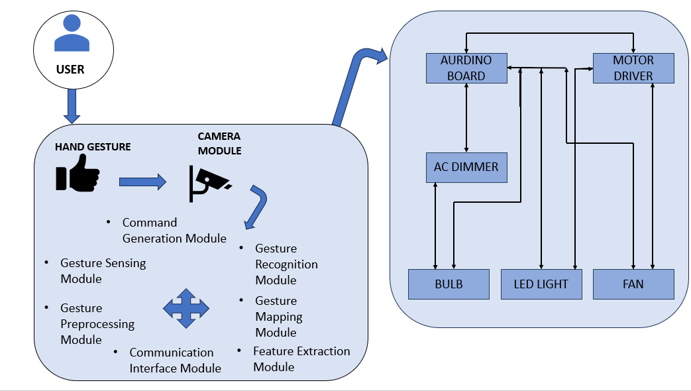

Fig.1. System Configuration Diagram

The heart of the gesture-based home automation system lies in the implementation of the CNN algorithm, renowned for its real-time object detection capabilities. For this project, CNN is tailored to recognize and interpret hand gestures associated with specific commands. The preparation of a diverse dataset is a pivotal step, comprising images of hand gestures corresponding to the defined commands. The dataset is used to train the CNN model, adjusting parameters such as learning rate, epochs, and batch size to optimize the model for accurate recognition.

Calibration of the system is crucial to ensuring its adaptability to various environmental conditions. This phase involves fine-tuning the gesture recognition algorithm and hardware components to account for different lighting conditions, distances, and user preferences. Subsequently, the calibrated system undergoes rigorous real-time testing to assess its responsiveness and accuracy in interpreting hand gestures.

1. Functionality of components

| Module | Functionality |
| --- | --- |
| Hand Gesture Recognition | Utilizes CNN algorithm to recognize hand gestures |
| Arduino Uno | Acts as the central microcontroller, interpreting and executing commands based on hand gestures |
| Fan Control | Turns on the fan at full speed when swing gesture detected; reduces the fan speed with thumbs up |
| Light Control | Activates bulb with higher brightness when fist is detected; reduces brightness with palm gesture |
| System Control | Shuts down the entire system when peace sign is detected |

The integration of hardware and software components necessitates the establishment of a robust communication protocol between the Arduino Uno board and the gesture recognition algorithm. This protocol ensures seamless interaction, enabling the hardware to respond promptly to the recognized hand gestures. Additionally, each recognized hand gesture is mapped to specific commands, defining how the system controls the fan speed, light brightness, and overall system state.

Performance evaluation encompasses a quantitative assessment of the system's accuracy in recognizing hand gestures and its responsiveness to user commands. The accuracy assessment is based on the model's ability to correctly identify and respond to gestures in real-time scenarios. Simultaneously, the responsiveness of the system is evaluated to ensure that it meets the real-time control expectations of users.

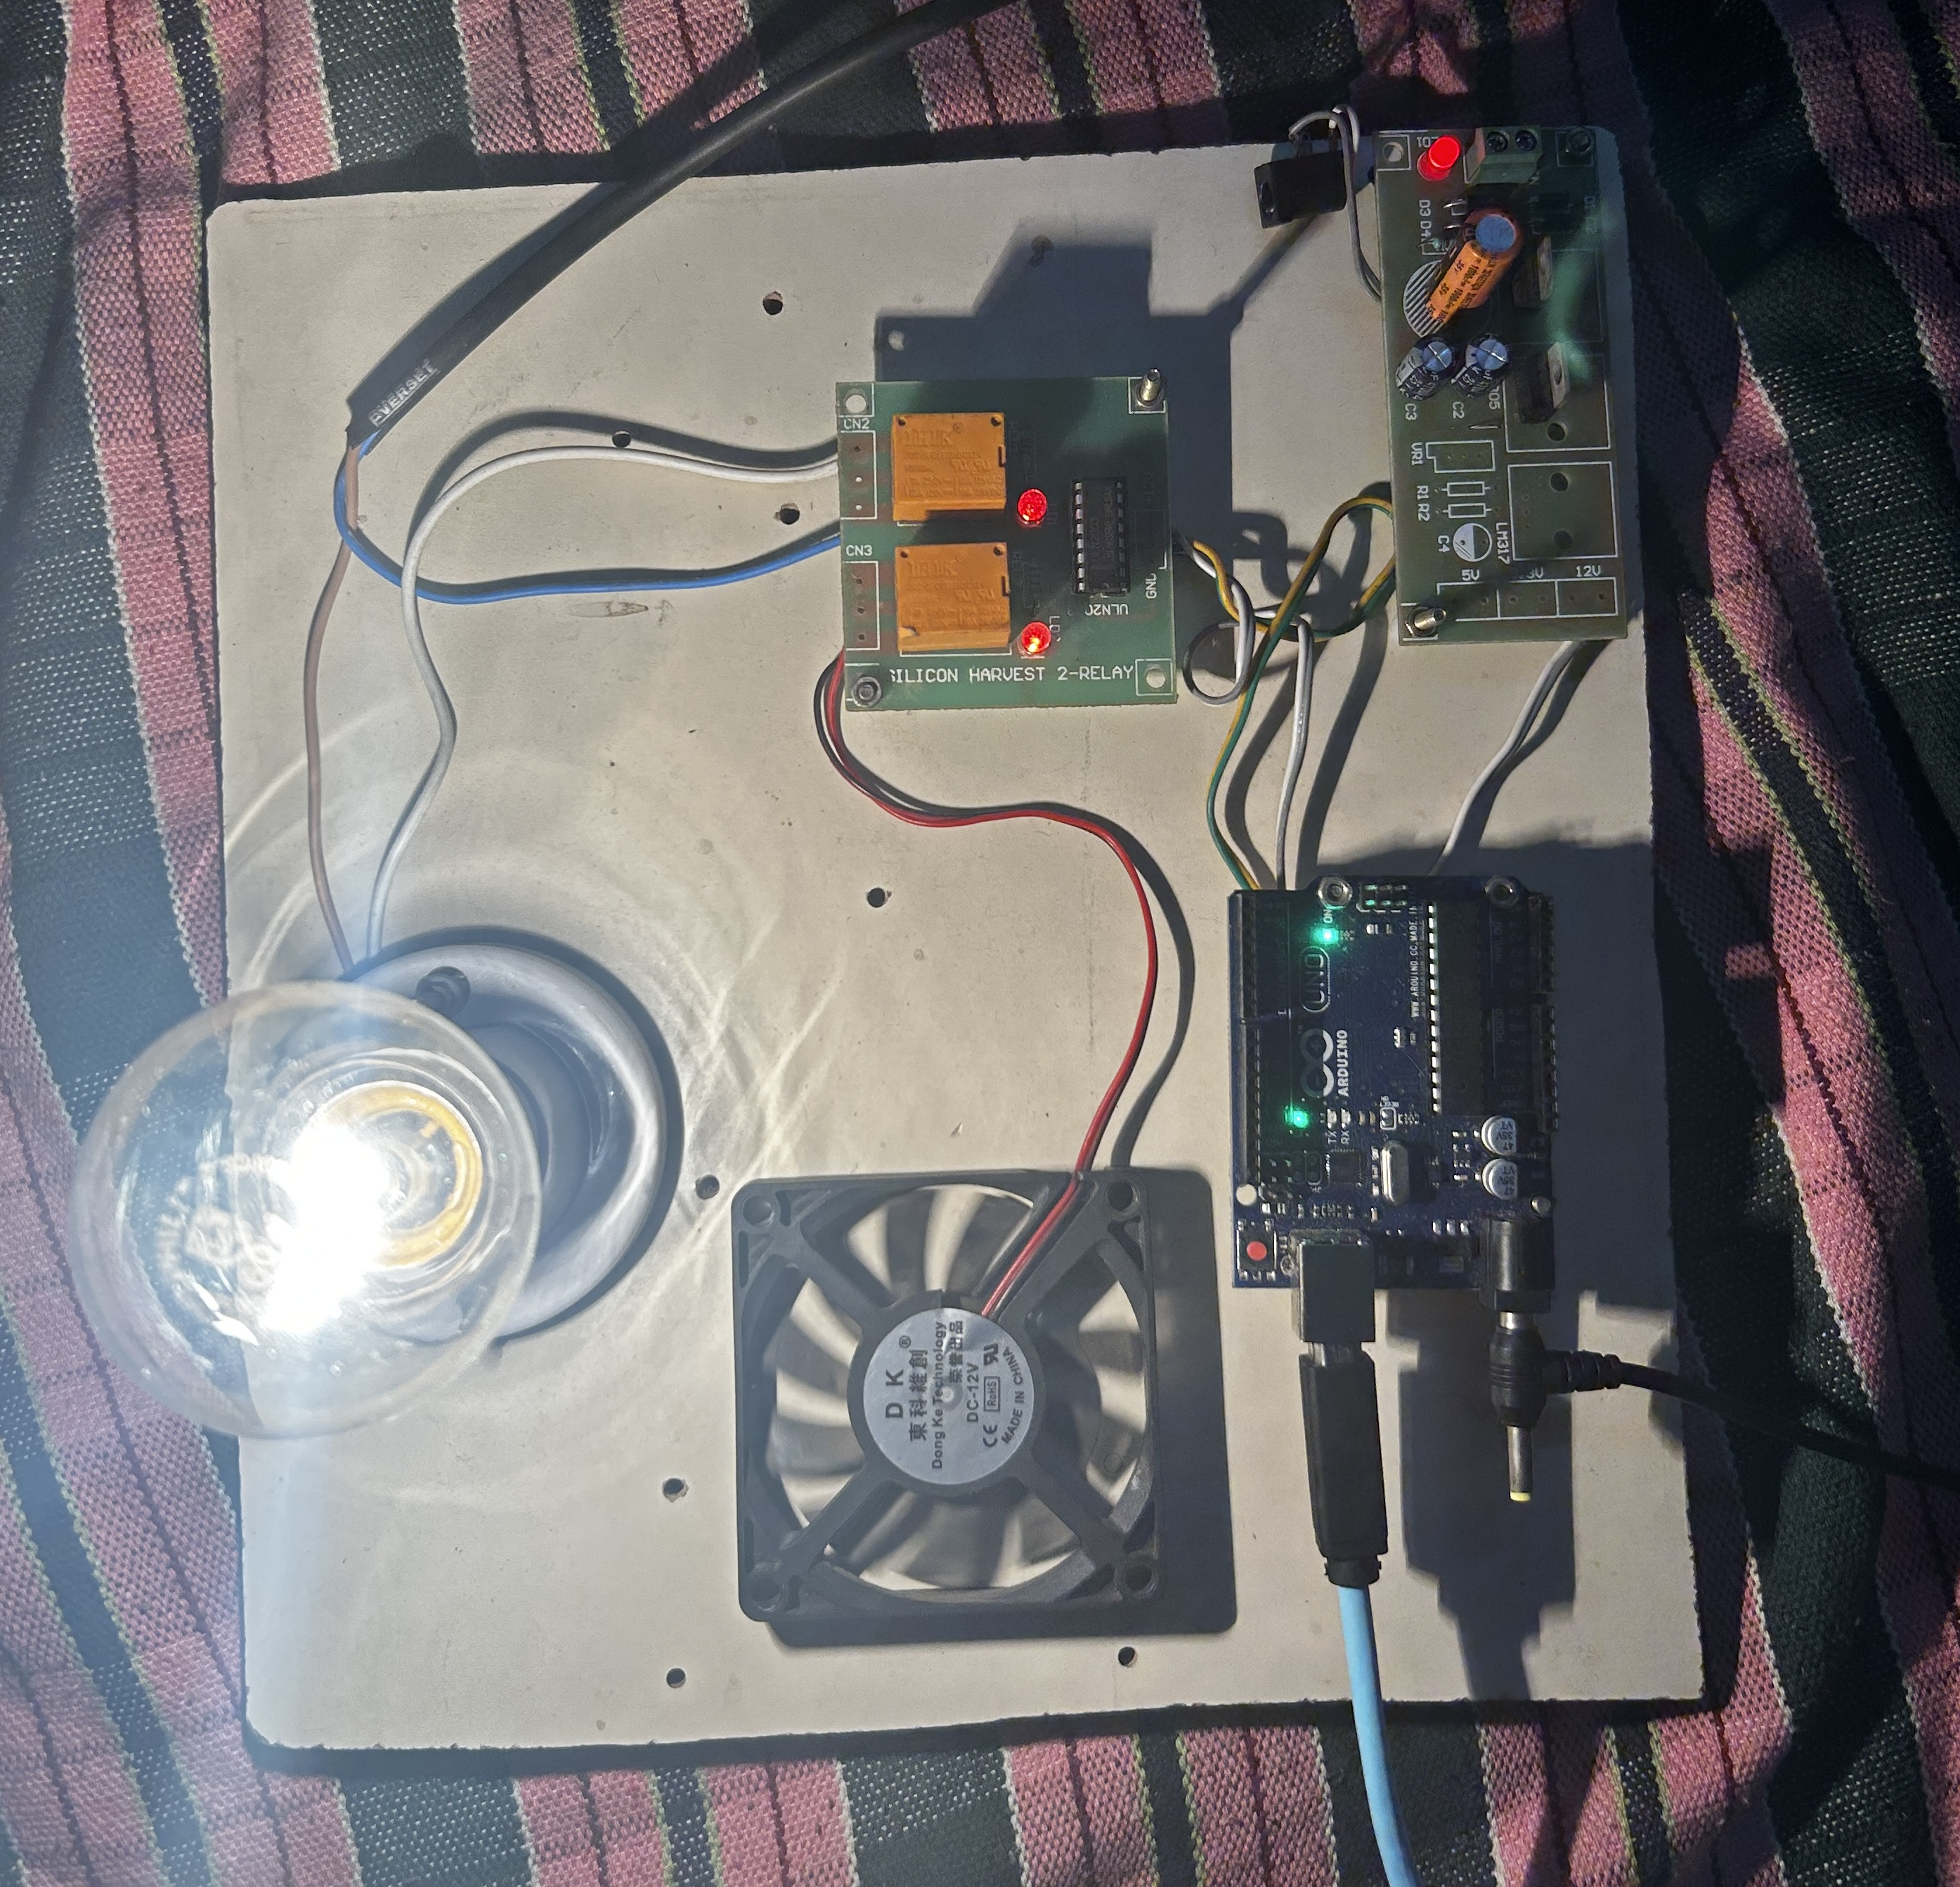

Fig.2. Hardware Setup

As an iterative process, optimization and refinement are integral to enhancing the system's performance. Iterative optimization involves addressing any identified issues and enhancing the overall performance based on the outcomes of testing phases. User feedback plays a crucial role in this optimization process, providing insights into user experiences and expectations. This iterative cycle ensures that the system aligns with user preferences, making it not only technically robust but also user-centric and adaptable to a variety of household scenarios.

This proposed methodology outlines a comprehensive and systematic approach to implementing a home-based automation system using hand gestures. Through careful integration of hardware and software components, rigorous testing, and iterative optimization, the methodology aims to deliver a robust, accurate, and user-friendly solution for gesture-controlled home automation. The significance of this research lies in its potential to bridge the gap between existing models' limitations and the user's desire for an intuitive and seamless interaction with smart home devices. In next section, we have discussed about the results.

# Results And Discussions

The implementation of a home-based automation system utilizing hand gestures has yielded promising results, marking a significant stride in the evolution of smart home technologies. The system seamlessly integrates hardware components, including an Arduino Uno board, a small fan, an LED light, a bulb, an AC dimmer, and a motor driver, with a hand gesture recognition algorithm based on the CNN model. Real-time testing scenarios were conducted to evaluate the accuracy of the gesture recognition algorithm, the responsiveness of hardware components, and the overall user experience. The CNN algorithm demonstrated commendable accuracy in recognizing hand gestures corresponding to defined commands, showcasing the effectiveness of the training process with a diverse dataset.

The hardware components exhibited swift responsiveness to the recognized hand gestures, enabling dynamic control of fan speed and light brightness. Users could intuitively manipulate the system through gestures, exemplifying the user-friendly interface. Comprehensive functionality testing demonstrated the versatility of the system, allowing users to control the fan speed, adjust light brightness, and shut down the entire system with simple hand movements. This intuitive control mechanism enhances the practicality and user experience of the proposed home-based automation system.

In a comparative analysis with existing models, the system showcased notable improvements, particularly in addressing common drawbacks associated with complexity and cost. The CNN algorithm, tailored for real-time object detection with a focus on hand gestures, contributes to a robust and cost-effective solution. The system's adaptability to varying environmental conditions was evaluated through real-time testing scenarios, where it consistently performed well. However, challenges were identified during the calibration process, highlighting the need for iterative adjustments to ensure optimal performance under different lighting conditions and distances. Additionally, the system's performance may be influenced by factors such as hand size and gesture variability, suggesting areas for further refinement.

1. Working Functions of Gestures

| Hand Gesture | Functionality |
| --- | --- |
| Swing | Activates full speed for the fan |
| Thumbs up | Adjusts fan speed to a lower setting |
| Fist | Activates higher brightness for LED light/bulb |
| Palm | Reduces brightness for LED light/bulb |
| Peace | Turns off the entire system |

Looking forward, potential avenues for future enhancements include expanding the gesture set to accommodate a broader range of functionalities and incorporating machine learning techniques for personalized gesture mapping. Furthermore, integration with existing smart home ecosystems, such as voice-controlled assistants or mobile applications, could enhance interoperability and provide users with multiple control options. Fig.3 Represents the working functionality of the proposed system .The practical implications of this research extend beyond the current implementation, positioning the proposed system as a viable, accessible, and user-friendly solution for a diverse user base. As smart home technologies continue to evolve, the seamless integration of intuitive hand gestures as a control mechanism holds the promise of reshaping the future of home automation. Ongoing research and iterative refinement will play a pivotal role in addressing challenges and advancing the capabilities of gesture-based home automation systems, contributing to a more intuitive and connected living experience. Fig.2 shows the recognised hand gestures using the CNN method .

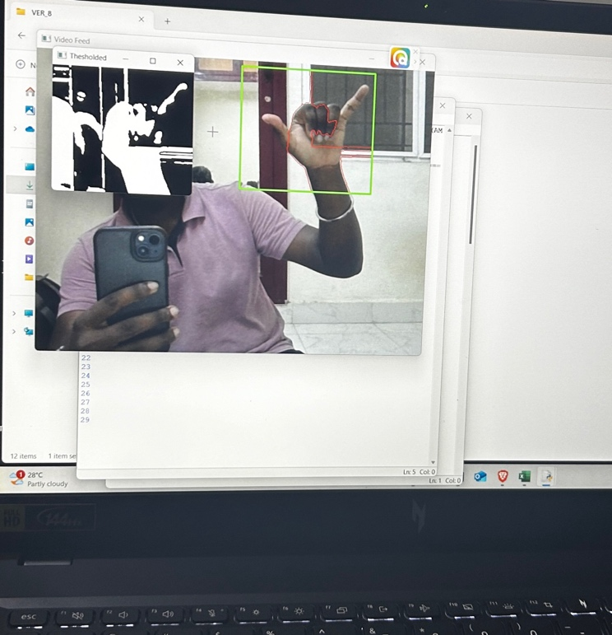

Fig.4.1. Gesture for Activating fan with full speed

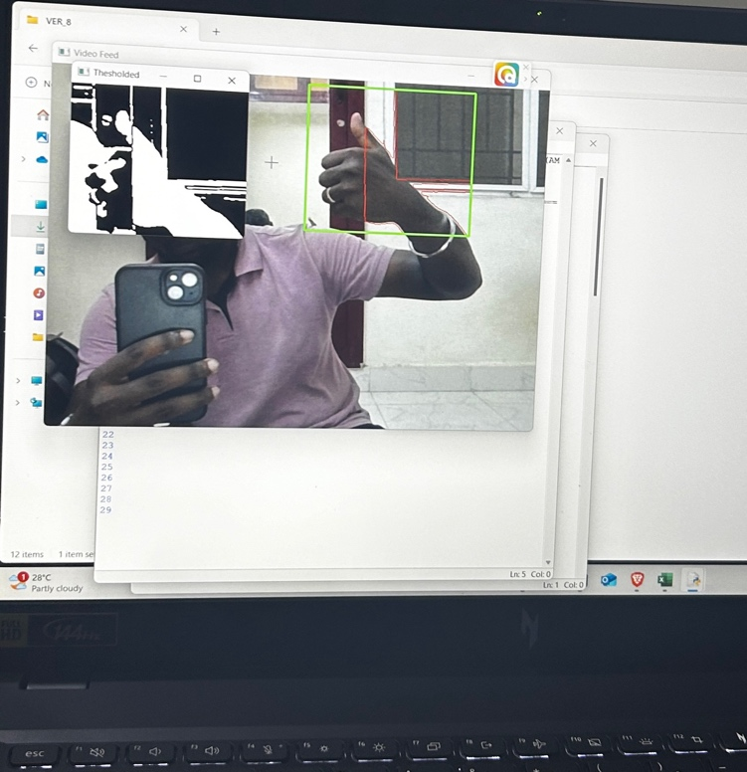

Fig.4.2. Gesture for reducing fan speed

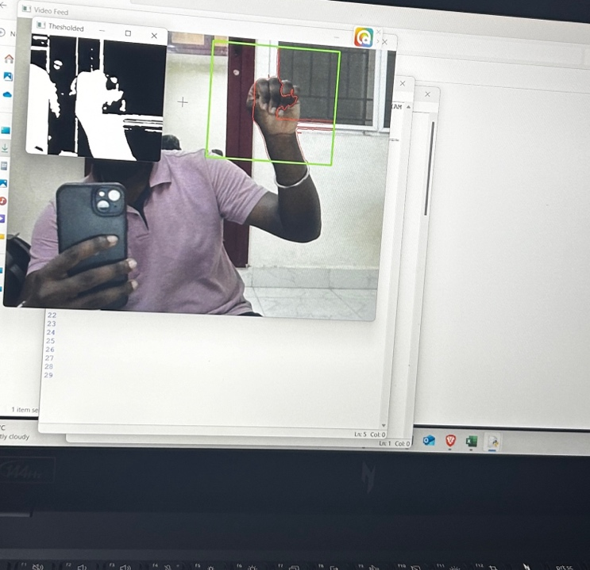

Fig.4.3. Gesture for Activating light with full brightness

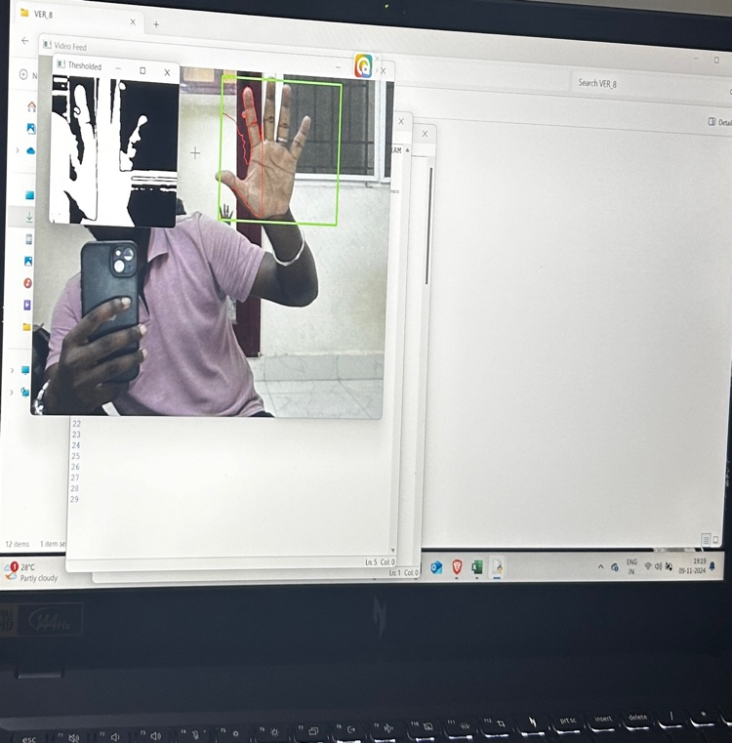

Fig.4.4. Gesture for reducing light brightness

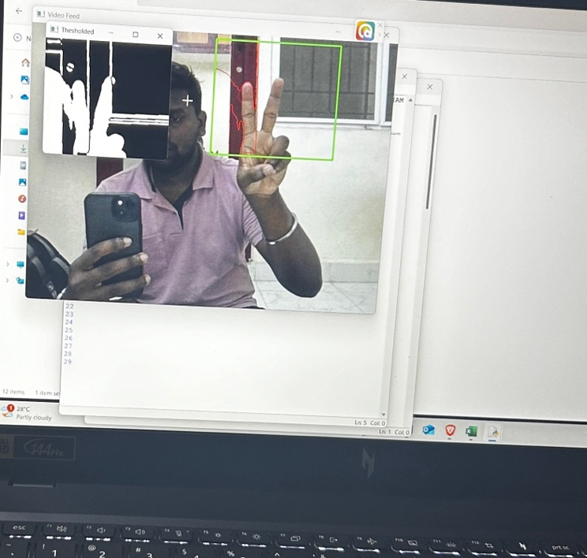

Fig.4.5. Gesture for turn off the entire system

# Conclusion

The culmination of our endeavor to develop a home-based automation system using hand gestures marks a significant milestone in the realm of smart home technology. Through meticulous design, implementation, and optimization, we have crafted a solution that offers unparalleled convenience, accessibility, and efficiency to users in controlling their household appliances.

Our system leverages advanced gesture recognition algorithms, sophisticated hardware components, and user-friendly interfaces to create an intuitive and seamless user experience. By harnessing the power of deep learning, we have enabled the system to accurately interpret a wide range of hand gestures in real-time, translating them into actionable commands for controlling lights, fans, and other smart devices.

One of the key strengths of our system lies in its emphasis on accessibility. By incorporating features such as voice commands, tactile feedback, and customizable gesture mappings, we have ensured that individuals with diverse needs, including those with disabilities or mobility impairments, can interact with the system effortlessly.

Furthermore, our system prioritizes efficiency and reliability, with optimization techniques implemented at every level to minimize latency, conserve energy, and enhance overall performance. From hardware acceleration to real-time monitoring, we have left no stone unturned in ensuring that the system operates seamlessly under various environmental conditions.

As we reflect on the journey from concept to implementation, it becomes evident that our home-based automation system has the potential to revolutionize the way people interact with their living spaces. Whether it's turning on the lights with a simple hand gesture or adjusting the fan speed with a flick of the wrist, our system offers users a glimpse into the future of smart home technology.

Our project stands as a testament to innovation, creativity, and the relentless pursuit of excellence. As we look ahead, we remain committed to further refining and enhancing our system, continually pushing the boundaries of what's possible in the realm of home automation. With each advancement, we strive to make everyday living more convenient, accessible, and enjoyable for users around the world.

##### References

1. Finger Gesture Recognition based Home Automation using IOT [2023] Neha G , Harika CH , Swetha G , Vishnu Kanth G .
2. Vision based Hand gesture pattern recognition enabled home automation system using Internet of Things [2021] R Jayanthi, A Bhuvaneswari, S Rajkumar, K P Rama Prabha.
3. IoT based enabling home automation system for individuals with diverse disabilities[2023] P. Anuradha , K. Vasanth , G. Renuka , A.Rajeshwar Rao .
4. IOT BASED HOME APPLICATIONS CONTROLING USING VISION AND GESTURE THROUGH RASPBERRY PI [2023] J L SARWANI Theeparthi ,Sape Chittibabulu.
5. Gestures Controlled Home Automation using Deep Learning: A Review [2021] A. D. Harale , Amruta S. Bankar and K. J. Karande.
6. HAND GESTURE RECOGNITION USING RECURRENT NEURAL NETWORKS AND SYNTHETIC DATA GENERATION [2023] F. SABBARESE , L. MAGLIULO, P. CARRATU , M. ROMANO.
7. Real-Time Monocular Skeleton-Based Hand Gesture Recognition Using 3D-Jointsformer [2023] Enmin Zhong , Carlos R. del-Blanco , Daniel Berjón , Fernando Jaureguizar and Narciso García.
8. Computer Vision based Media Control using Hand Gestures [2023] Sangamesh Narayanpethkar, Abhishek Makude, Samrudh S, Yashraj Khose, A. D. Gujar.
9. Convolutional neural networks framework for human hand gesture recognition [2023] Aseel Ghazi Mahmoud, Ahmed Mudheher Hasan, Nadia Moqble Hassan.
10. [10] Improving Real-Time Hand Gesture Recognition with Semantic Segmentation [2021] Gibran Benitez-Garcia , Lidia Prudente-Tixteco , Luis Carlos Castro-Madrid , Rocio Toscano-Medina
11. Artificial Intelligence Based Smart Home Automation System Using Internet of Things [2021] Dr.China Venkateswarlu Sonagiri Dr Puralasetty Ashok Babu , Vijay Vallabhuni , Sivanagaraju Veerastu.
12. Utilizing ML for Hand Gesture Recognition [2023] Vaidish Srivastava , Srajan Shukla, Radhey Shyam.
13. Gesture Vocabularies for Hand Gestures for Controlling Air Conditioners in Home and Vehicle Environments [2023] Hasan J. Alyamani .
14. HOME AUTOMATION SYSTEM [2023] Mafidul Islam, Deepjyoti Mahanta, Dr. Kaustubh Bhattacharyya, Maidul Islam.

[15] Hand Gesture and Voice Assistants [2023] B. Latha, Sri Sowndarya, Swethamalya.K, Mr.Ashish Raghuwanshi,Rakhmatova Feruza,Mr.G. Sathish kumar.